AD NAME:
- PRINCIPAL HORN with duty of second horn, third horn and following and Wagner Tuba

(n. 1 permanent position)

Online start data: from 29 NOVEMBER 2025 - Online end data: 18 JANUARY 2025
Closing date for applications: 18 JANUARY 2025 (included)
Application address:
https://www.teatroallascala.org/en/the-theater/work-with-us/orchestra-auditions.html
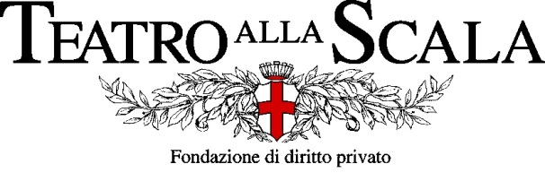
The Teatro alla Scala Foundation is holding an international public competition for the permanent position of:
PRINCIPAL HORN with duty of second horn,
third horn and following and Wagner Tuba N. 1 permanent position
The Principal Horn position corresponds to the 2nd level artistic‐area, according to current
collective contractual regulation and to Contratto Scala, with a gross annual salary of € 82.701,30.
Admission Criteria
a) be at least 18 years of age;
b) citizenship of a European Union country or non‐EU citizenship with long‐term residence
permit, refugee status or subsidiary protection status; the hiring of successful candidates is
subject to regularization of their position regarding their residence permit in Italy for
employment purposes;
c) hold a higher education diploma in the instrument in question, obtained at a national
conservatory or an equivalent title;
d) physical idoneity for the job. The hiring of the winning candidates is subject to the
verification of the aforementioned suitability through a medical examination that will be
arranged upon indication of the Teatro alla Scala Foundation Management.

The candidates must have the requirements above mentioned on the date of issue of the
competition announcement.

Application Form
Application form (and any other documentation required) must be sent exclusively through form
online on the website www.teatroallascala.org selecting the page “work with us” ‐ “competitions
and auditions” in accordance with the instructions available, no later than January the 18th, 2026.
There is a payment for participation in the Competition of € 50.00 including VAT, to be paid online
at the time of registration, the main credit/debit cards are accepted. The above fee will be refunded
only in case of actual attendance at the exams.
At the end of the application process, an e‐mail will be sent to confirm the correct registration to
the competition.

Applications delivered by mail, fax, hand or email will not be accepted.
The Teatro alla Scala Foundation does not assume any responsibility for any technical or IT mistakes that do not allow the prompt submission of the applications.
For the complete ad and application process please read the document or visit the website: https://www.teatroallascala.org/en/the-theater/work-with-us/orchestra-auditions.html

